STEP 1: PYTHON INSTALLATION

* Python 3.8 should be installed initially. To install python 3.8 open terminal and in cmd

~$ sudo apt-get install python3.8 python3.8-dev python3.8-distutils python3.8-venv

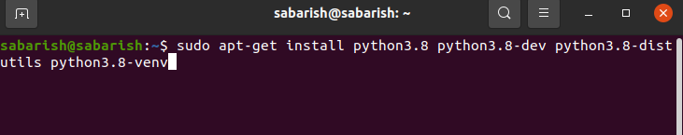
* To check whether it is installed or not

~$ python3 –version

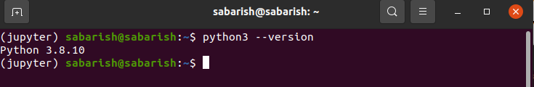
STEP 2: FOLDER STRUCTURE

* To create the folder structure go to the respective path you’ve allocated for installation and create a following directory

* API *Python_Environment

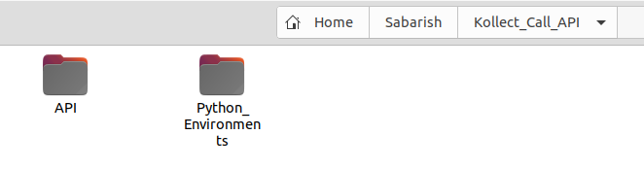
In API folder paste the source file and extract the file

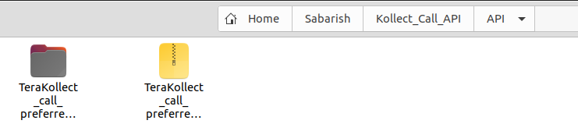

STEP 3: ENVIRONMENT SETUP

* Create the virtual environment and install necessory libraries to the respective enviroment. To create the virtual environmet,first to install virtual environment setup

~$ sudo apt install python3-venv

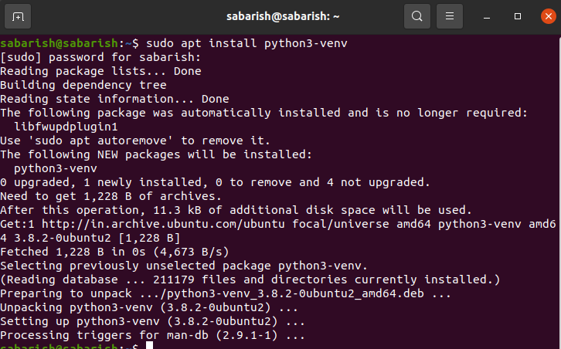

and followed by to create the virtual environment in Python_Environment folder we’ve created

~$ python3 -m venv Sabarish/Python_Environments/python3.8_kollectcall_preferred_session

here Sabarish/Python_Environments is the path for installing python environment and python3.8_kollectcall_preferred_session is the environment name

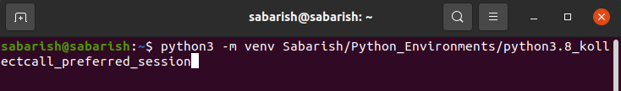

once the environment installed you may find the folder in the respective path you’ve mentioned

* To activate the created python environment

~$ source Sabarish/Python_Environments/python3.8_kollectcall_preferred_session/bin/activate
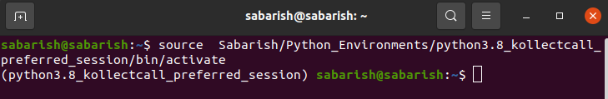

here environment path followed by environment name and then /bin/activate will activate your environment. you may find the environment name in terminal

* Now install the necessory libraries created environment. first navigate to project directory we’ve extracted and in that find requirement folder & in that requirement.txt have the all the necessory libraries

~$ pip install -r Sabarish/Kollect_Call_API/API/TeraKollect_call_preferredSession/requirement/requirements.txt

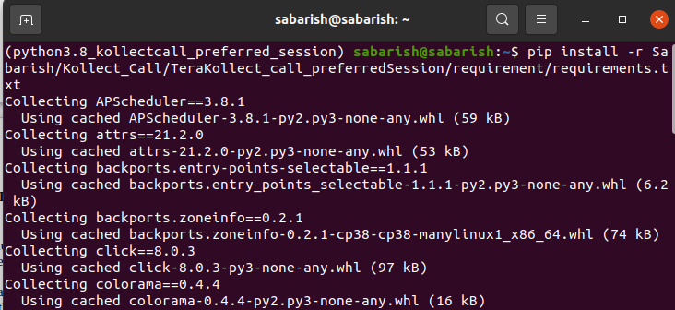

it will take some time based on the libraries we’ve used

STEP 4: DATABASE PREREQUISITES

* Fetching data from the customer$information table and make sure below fields are exist in that table

~$ SELECT ID, GENDER, CUSTOMER_RISK_STATUS, INDUSTRY, RESIDENCE, CUSTOMER_STATUS, PROMISE_SUCCESS, TIME_STAMP, REPAY_CURRENCY, STAGE from customer$information

* In further need two table’s to store the model information and input/output details
1) classification$model$information
2) classification$model$prediction
you may find the DDL script in project file under MYSQL folder and do execute the script.

* one last to execute the insert scripts in the insert_classification$model$information.sql under MYSQL folder in project directory

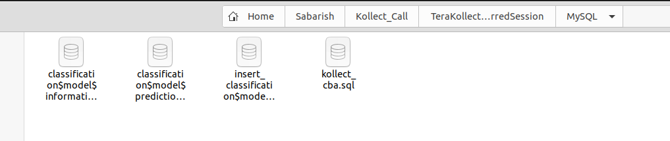

STEP 5: APPLICATION PREREQUISITES

* we are almost done, on last final step to setup is to set up database credentials in config file. To do that in source file go to the config folder and open config.sh using notepad. In that change the values as per the requirement

To encrypt the MYSQL password do the below
* Activate the environment as per above commands
* Nagavigate to project directory using above guidance
and do the follow

~$ source config/config.sh

~$ python3 -c 'from pyfiles.encryption import live_passkey_encryptipn;
print(live_passkey_encryptipn("PASSWORD_STRING"))'
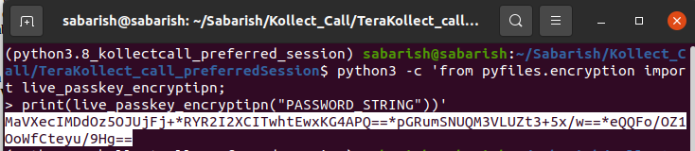
Replace password string with the respective password and enter you will get the encrypted string . Replace the encrypted string with LIVE_MYSQL_PASSWORD string

export LIVE_MYSQL_USER="root"
export LIVE_MYSQL_PASSWORD="5WWLgw==*1ahuUFcWTl2sRKbQ==" # Password encrypted
export LIVE_MYSQL_HOST="127.0.0.1"
export LIVE_MYSQL_PORT=3306
export LIVE_MYSQL_DB="kollect_cba"

STEP 6 : RUN OUR APPLICATION

* To run our application first to active the python environment we’ve created initially. To active the environment navigate the respective directory and do activate

~$ source Sabarish/Python_Environments/python3.8_kollectcall_preferred_session/bin/activate
* Next, to active the configuration files which has the DB related information. To active the config file navigate to project directory and execute below commands

~ $ cd Sabarish/Kollect_Call_API/API/TeraKollect_call_preferredSession/

~$ source config/config.sh
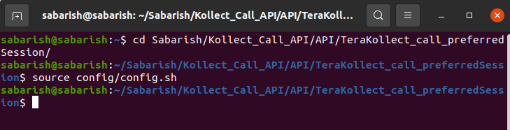

* To exceute the application as background process

~$ nohup python3 Kollect_preferredSession_app.py &
or
~$ nohup python Kollect_preferredSession_app.py &

and close the terminal further

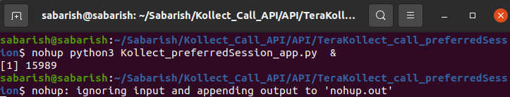

STEP 7: VALIDATE APPLICATION RUNNING OR NOT

* once application is up, the application creates the log files in source file directory under folder log named errorlog.log. You may open using notepad and see the latest time you’ve started the application.
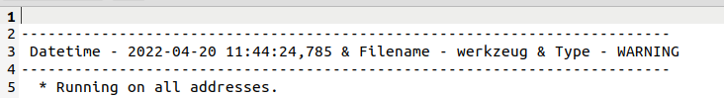

* In another way we may pass the respective url and input details in postman to get our respective output

METHOD TYPE : post
URL: http://127.0.0.1:2012/kollectCall_preferredSession_xgbClassifier_modelPredictions
INPUT: {
"ID":816852,
"CUSTOMER_RISK_STATUS":"A20",
"INDUSTRY":1030,
"RESIDENCE":"KE",
"GENDER":"FEMALE",
"PROMISE_SUCCESS":"YES",
"REPAY_CURRENCY":"KES",
"CUSTOMER_STATUS":"NORMAL CLIENT",
"STAGE":"COLLECTION"
}

and you’ll get the respective output as mentioned
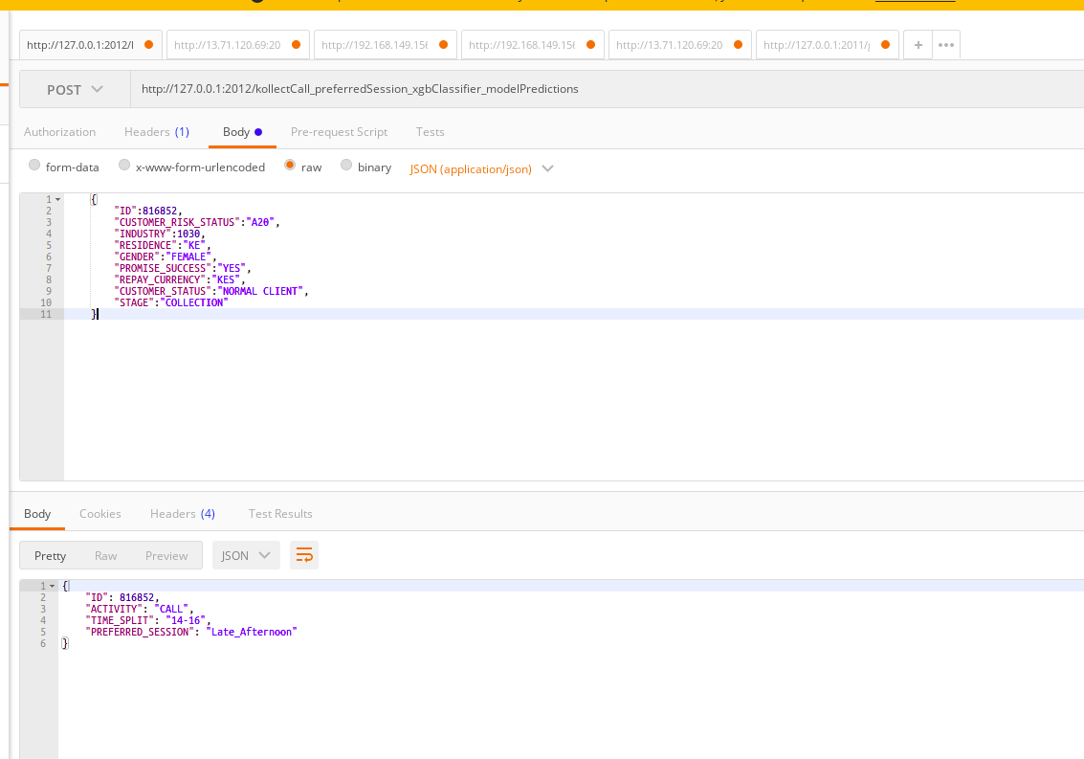

* FURTHER VERSION’S DEPLOYMENT

In the above we’ve seen how to deploy the fresh version.here quickly brief how to deploy the next and further releases

* Extract the latest file to the destination folder
* Activate the respective python environment using above commands
* navigate to the repective project directory in terminal

* First step to terminate the process we’ve executed already in past. We’re running our application in port no 2012 and going to kill our process using port number. To do that in cmd

~$ sudo kill -9 $(sudo lsof -t -i:2012)
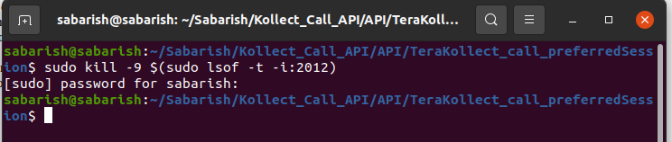

and to Run our application again

~$ nohup python3 Kollect_preferredSession_app.py &
or
~$ nohup python Kollect_preferredSession_app.py &

and close the terminal further

and this need’s to be validated further, whether the application running or not using the above methods mentioned

